# Artem Saharov, Dmitry Beresnev, Erik Starodubskiy, Alexander Morozov

# HIL 1 WEEK 9 EXERCISES

1. **ANSWERS in ½ page A4**
   1. *Summarise and explain the steps involved in building a truth table*  
      To create a truth table we firstly have to determine the number of lines(L). It is equal to 2 in a power of a number of different variables, so L = 2^n. Then we have to construct n + number of operators columns. In the first n columns we should write our variables. Then we have to write all possible values for the variable: for the first one we write L/2 “T” and L/2 “F”, for the second variable L/4 “T” and L/4 “F” repeats and so on. In the last columns we write expressions we get from adding one-by-one new operators according to the execution order for logic equations (brackets first, negation second, conjunction third,...)
   2. *What are tautological, self-contradictory, and contingent statements***Tautology**: when all values under main operator are True  
      **Self-Contradictory**: when all values under main operator are False  
      **Contingent**: values under main operator are mixed
   3. *Explain the difference between logically equivalent, contradictory, contingent, and non-contingent statements*

**Logically equivalent:** for two statements, if values under main operator of corresponding lines in both statements are the same (“T” - “T”, “F” - “F”)  
**Contradictory:** for two statements, if values under main operator of corresponding lines in both statements opposite (“T” - “F”, “F” - “T”)

**Contingent:** see above  
**Non-Contingent:** Tautology, Self-Contradictory

**Consistent:** There is at least one line in which both statements are True

**Inconsistent:** There is no one line in which both statements are True

# CLASSIFY THE FOLLOWING STATEMETS:







**CONTINGENT**

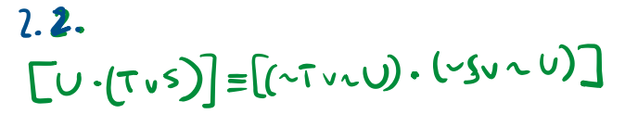

**CONTINGENT**

# COMPARE THE FOLLOWING STATEMENTS:

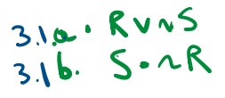

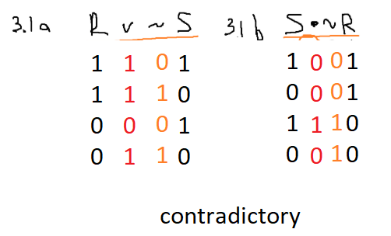

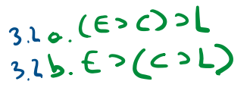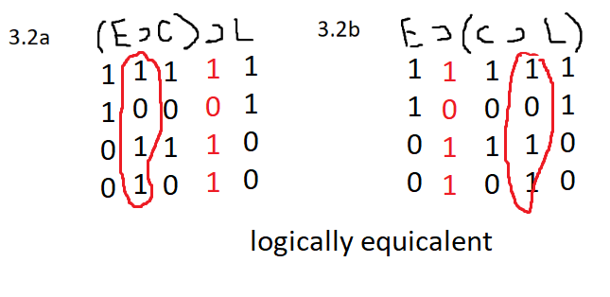

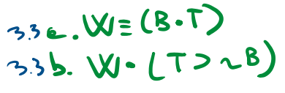

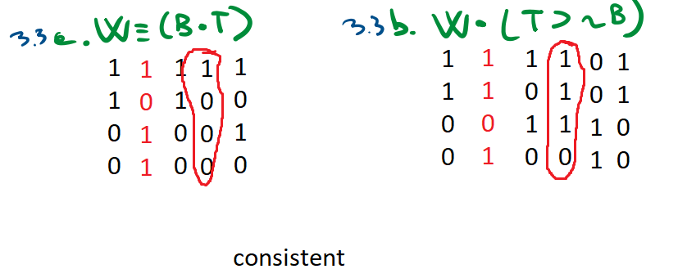

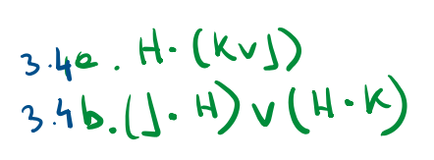

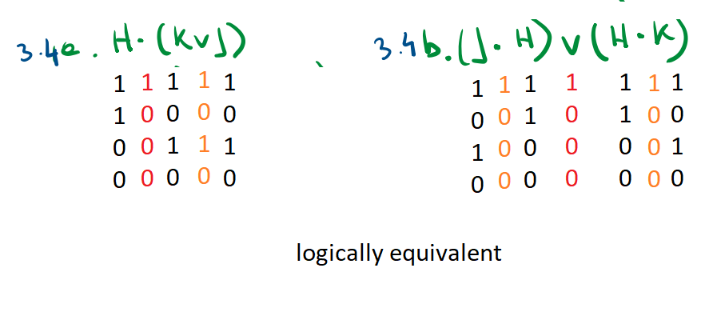

# DIAGRAM THE FOLLOWING PASSAGE

(1)Trying to promote just narrow religious tolerance alone is a bad idea. (2) Religious tolerance requires only that one does not object too much to the practice of a religion other than one’s own. (3)Much better is that one understands it as well. (4)Besides, religious tolerance alone may foster intellectual error. (5)For example some people who are narrowly tolerant to religions may insist (6)that all religions are essentially the same, even doctrinally. (7)That’s a mistake. (8)If there is just one god then there can’t be many, so(9) Islam and Hinduism can’t both be correct. (10)And if Mohammed is the true prophet then Christ isn’t the true prophet,(11) so Islam and Christianity can’t both be correct. (12)Moreover, Promoting religious tolerance, whether in the narrow sense or in a wider sense, involves not objecting to religion in general. (13)But the practice of *any* religion is objectionable. (14)Religion is anti-scientific and scientific is certainly what we should all be.(15) And we wouldn’t have religious wars if religion wasn’t practiced.

